Project Documentation
Project Report
Date | 03 November 2026
Roll Number | 323103282099
Project Name | Incident Lifecycle Automation in ServiceNow

1. Introduction

1.1 Project Overview
This project automates the full Incident Management lifecycle in ServiceNow. I took a single VPN outage scenario and carried it from the first phone call all the way to a new knowledge article. Along the way it touches the Service Desk, the Network Level 2 team and Change Management, and the SLAs are tracked from start to finish.
Service Desk agents log and classify incidents in Service Operations Workspace and use Agent Assist to find knowledge. Level 2 technicians investigate, raise an emergency change, track repeat reports as child incidents and document the fix. That fix is then saved as a knowledge article so the next agent does not have to start from scratch.

1.2 Purpose
- Standardize how incidents are created and classified (category, subcategory, urgency, service, CI).
- Bring Knowledge Management into the agent's daily work so issues get resolved faster.
- Reassign incidents to the right support groups and Level 2 technicians.
- Raise emergency change requests that are linked to the incident.
- Track recurring issues using child incidents.
- Create knowledge articles from resolved incidents.
- Improve SLA compliance and service visibility.

2. Ideation Phase

2.1 Problem Statement
Incidents are often logged with missing details, routed by hand and fixed without reusing what the team already knows, so SLAs slip. I wanted a standard lifecycle in ServiceNow that connects incident, knowledge, change and SLA data on one record.

2.2 Empathy Map Canvas
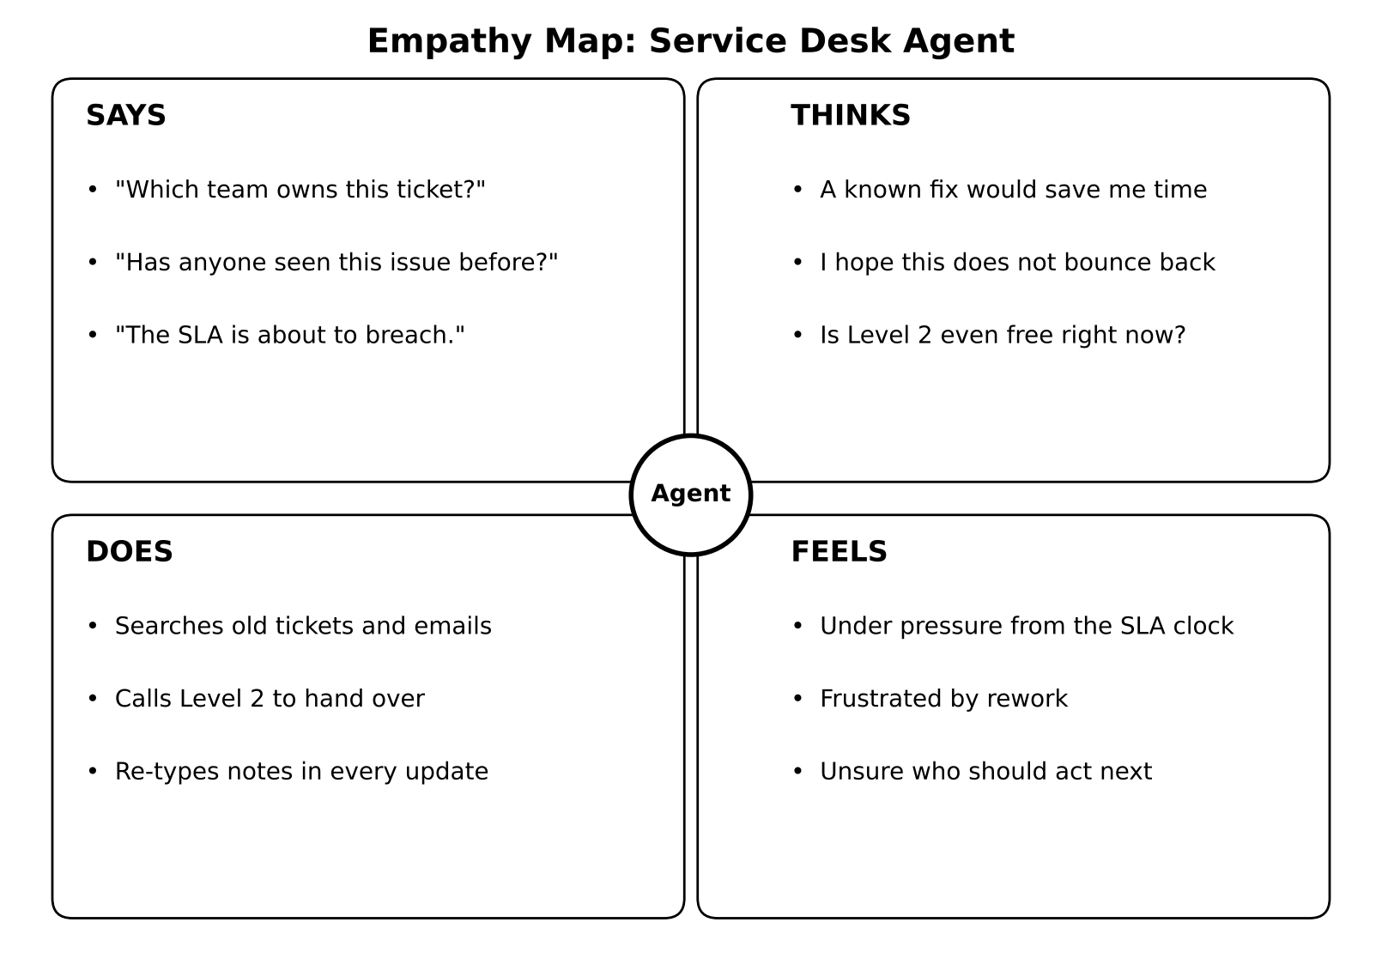
Figure 1: Empathy map for the Service Desk agent

2.3 Brainstorming
I listed ideas for every stage of the lifecycle and placed them on an impact versus effort grid. The quick wins (classification, Agent Assist, assignment groups and SLA tracking) were built first, followed by the larger pieces.
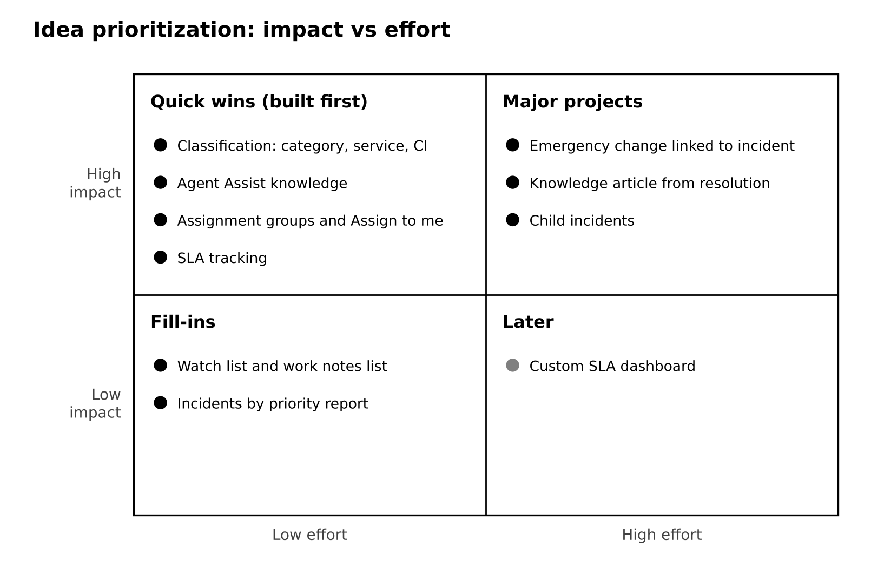
Figure 2: Idea prioritization grid

3. Requirement Analysis

3.1 Customer Journey Map
Stage | Touchpoint | How the solution helps
Report | Phone call to the Service Desk | One incident record holds the whole story
Log and classify | Service Operations Workspace | Category, service, offering and CI are captured
Diagnose | Agent Assist | Matching knowledge articles appear from the short description
Escalate | Assignment group, Assign to me | Clear owner at every step
Change | Emergency change request | Change linked; incident waits On Hold
Resolve | Resolve action, child incidents | Child incidents close with the parent
Learn | Create Knowledge | The fix is saved as an article

3.2 Solution Requirement
FR No. | Functional Requirement | Details
FR-1 | Incident creation | Caller, short description, description, channel
FR-2 | Classification | Category, subcategory, impact, urgency, service, offering, CI
FR-3 | Knowledge integration | Agent Assist search, attach, mark helpful
FR-4 | Assignment and escalation | Groups, Assign to me, watch list, work notes list
FR-5 | Level 2 investigation | Update CI, On Hold with reason Awaiting Change
FR-6 | Emergency change | Change request linked to the incident
FR-7 | Child incidents | Child resolves with the parent
FR-8 | Resolution | Cause, resolution code, resolution notes
FR-9 | Knowledge creation | Article created from the incident
FR-10 | SLA tracking | Response and resolution SLAs in Task SLAs

Non-functional requirements covered usability (one workspace screen), security (role-based access), reliability (full Activity history), performance (no custom scripts), availability (cloud hosted) and scalability (configuration only).

3.3 Data Flow Diagram
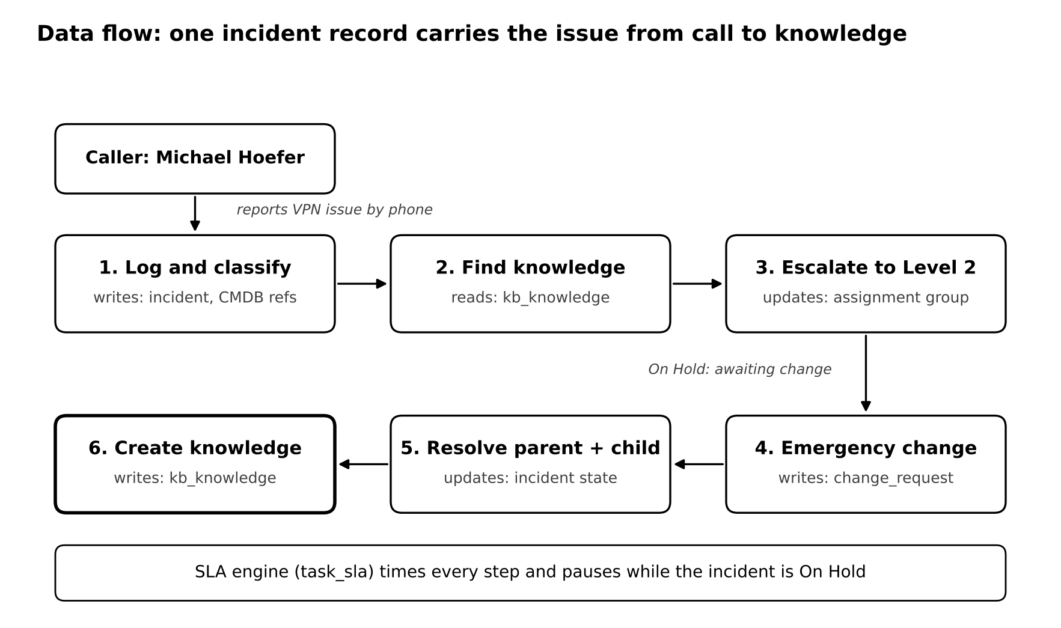
Figure 3: Data flow of the incident lifecycle

3.4 Technology Stack
Component | Technology
User interface | Service Operations Workspace and Classic UI
Incident lifecycle | ServiceNow Incident Management
Knowledge | Knowledge Management and Agent Assist
Change | Change Management (emergency change)
SLA | Service Level Management
Configuration data | CMDB: Business Service, Service Offering, Server CI
Infrastructure | ServiceNow cloud, Personal Developer Instance

4. Project Design

4.1 Problem Solution Fit
The customers are Service Desk agents, Level 2 technicians and IT managers. Their job is to resolve incidents within SLA, and the trigger is a user reporting an outage. Today they rely on emails, calls and spreadsheets, which have no SLA timer and no link to change or knowledge. The root cause is the lack of a standard lifecycle, and that is exactly what this project provides.

4.2 Proposed Solution
Parameter | Description
Problem statement | Incidents are handled inconsistently and without reusing knowledge, so SLAs get missed
Idea / solution | A full incident lifecycle in Service Operations Workspace connecting knowledge, Level 2 escalation, emergency change, child incidents and SLAs
Novelty | The whole story lives on one incident record and its Activity stream
Customer satisfaction | Faster and more consistent fixes for users; less searching for agents
Business model | Lower cost per ticket and fewer SLA breaches using the existing licence
Scalability | New services, groups and SLAs are added as configuration

4.3 Solution Architecture
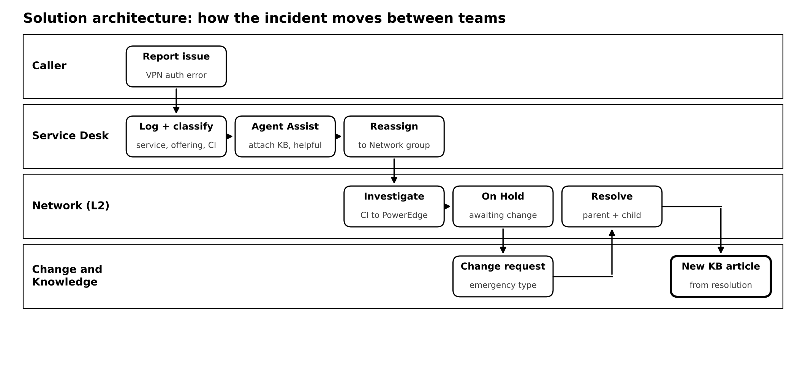
Figure 4: How the incident moves between teams

5. Project Planning & Scheduling

5.1 Project Planning
Sprint | Focus | Story Points | Dates
Sprint-1 | Users, groups, knowledge article, service hierarchy, SLA definition | 12 | 13 Oct to 31 Oct 2026
Sprint-2 | Incident creation, classification, Agent Assist, collaboration | 10 | 01 Nov to 02 Nov 2026
Sprint-3 | Level 2 tracking, emergency change, child incident | 12 | 02 Nov to 03 Nov 2026
Sprint-4 | Resolution, knowledge creation, SLA check, testing, demo | 13 | 03 Nov 2026

In total there were 47 story points over 4 sprints, which gives a velocity of 47 / 4 = 11.75 points per sprint.
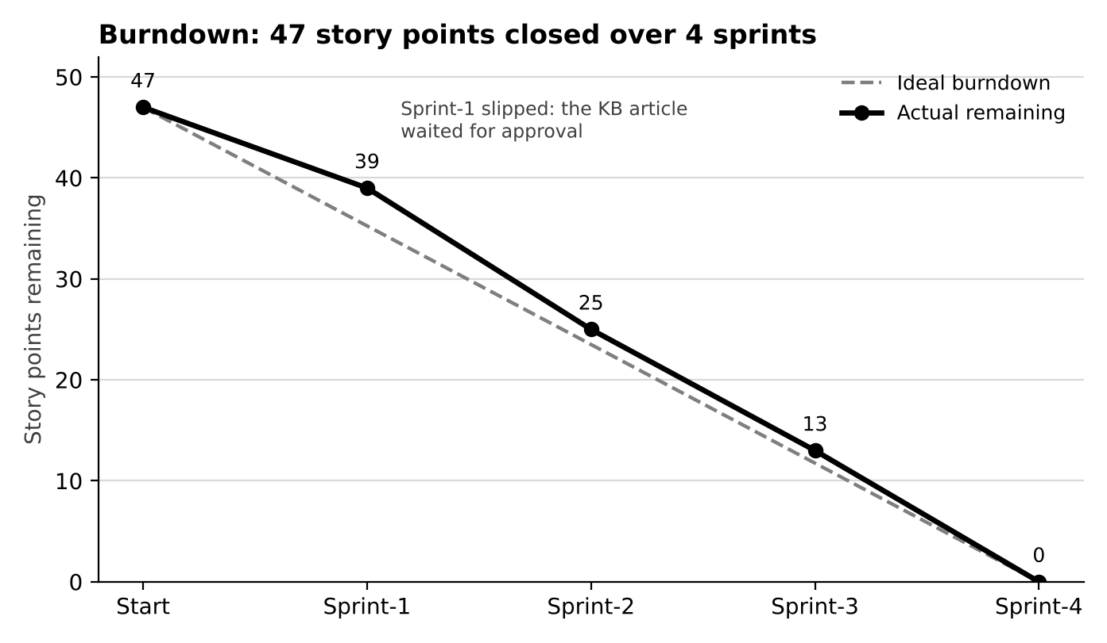
Figure 5: Burndown chart

6. Functional and Performance Testing

6.1 Performance Testing
Test | Expected Result | Actual Result | Status
Incident lifecycle end to end | New, In Progress, On Hold, Resolved | All state changes in Activity; State = Resolved | Pass
Escalation process | Service Desk to Network, David Loo | Assignment group = Network, Assigned to = David Loo | Pass
Change integration | Emergency change linked | CHG0030003 lists INC0010005 | Pass
Knowledge creation | Article from resolved incident | Created Knowledge (1), Attached Knowledge (2) | Pass
Child incident management | Child resolves with parent | INC0010006 Resolved | Pass
SLA tracking | SLAs with stage and breach | Task SLAs (4): Completed and Paused | Pass
Multi-team collaboration | Watch and work notes lists saved | Samantha Bordwell, Beth Anglin | Pass

All 7 tests passed. The Priority 4 response SLA breached (112.5% of its 8-hour target) because the incident waited before someone picked it up, while both resolution SLAs paused correctly when the incident went On Hold and then Resolved.

7. Results

7.1 Output Screenshots
These screenshots were taken from my instance while I worked through the scenario. They follow the same order as the lifecycle.
1. Service offering
I created the Corporate VPN offering and linked it to the Remote Access service.
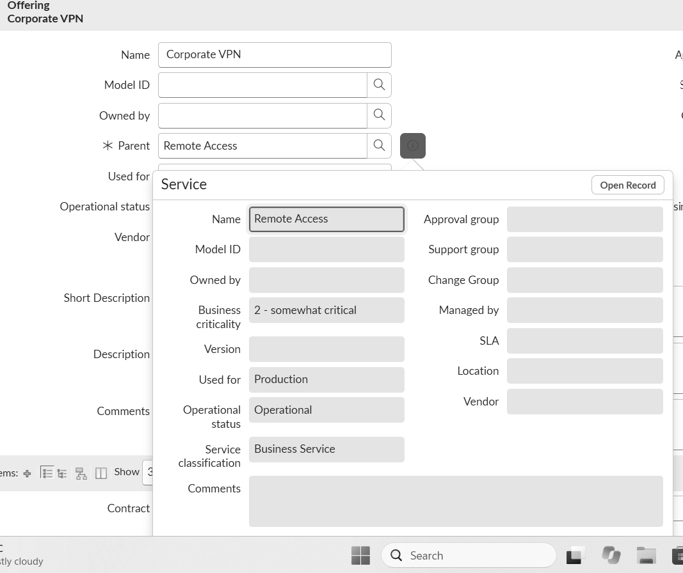
Corporate VPN with Parent = Remote Access
2. Incident classified
INC0010005 logged by Beth Anglin with category, subcategory, channel, urgency and CI filled in.
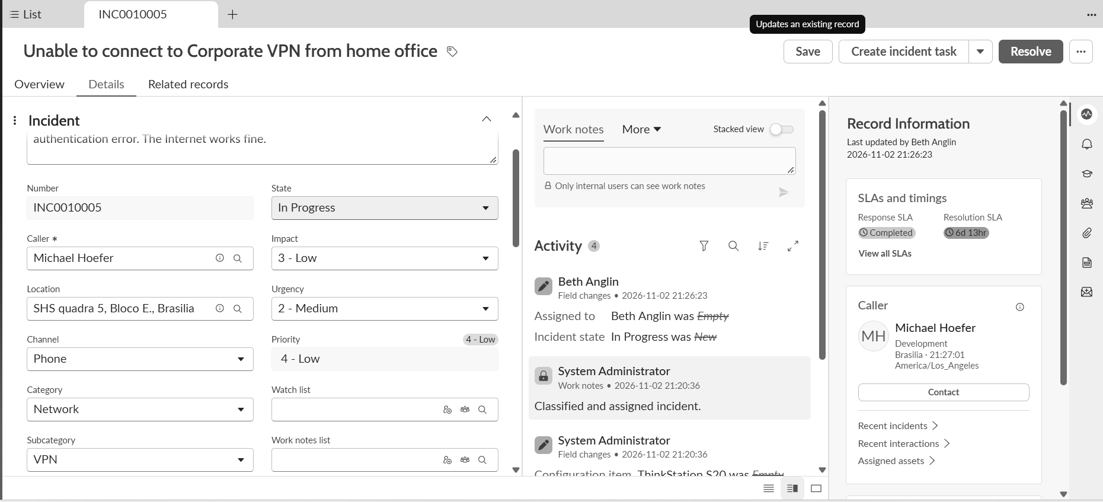
INC0010005 classified as Network / VPN
3. Knowledge attached
Agent Assist found a VPN article. I marked it helpful and attached it, and added the watch list and work notes list.
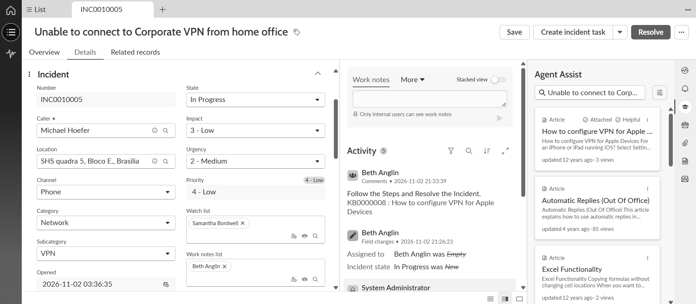
Article marked Attached and Helpful
4. Waiting on the change
David Loo changed the CI to the PowerEdge server and put the incident On Hold until the change was done.
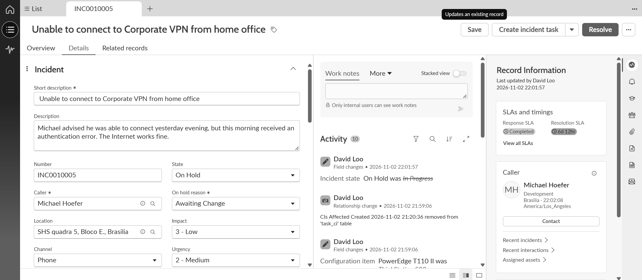
On Hold with reason Awaiting Change
5. Escalated to Level 2
The incident moved to the Network group and David Loo, with the probable cause recorded.
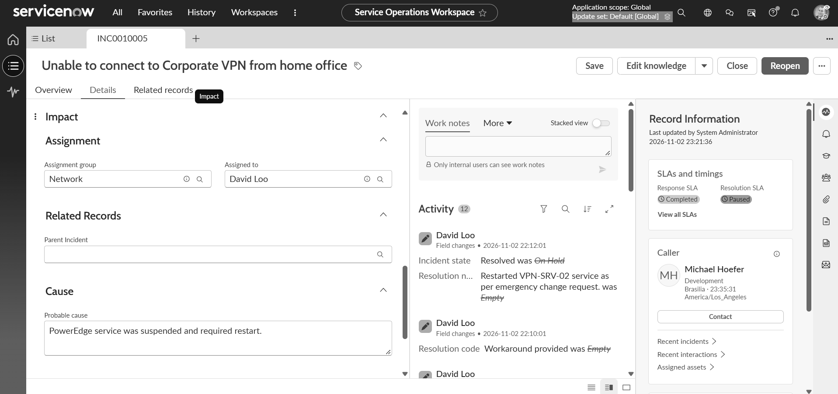
Assigned to Network and David Loo
6. Emergency change linked
CHG0030003 shows INC0010005 in its Incidents tab.
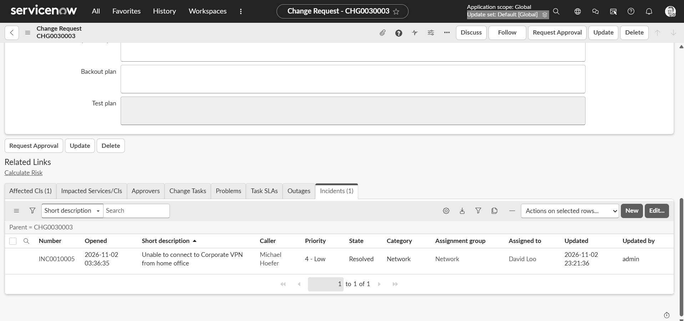
Emergency change CHG0030003
7. Child incident
A second user reported the same problem, so I logged it as child incident INC0010006.
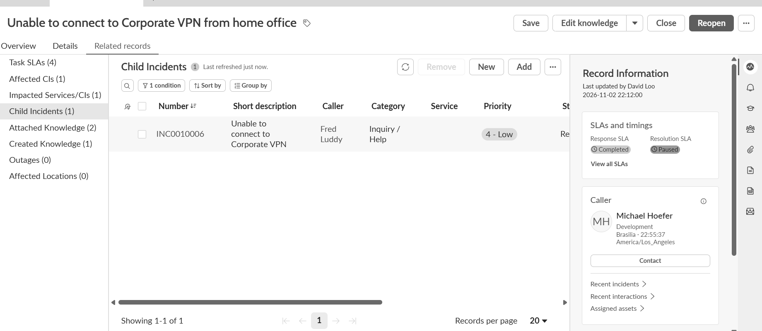
Child incident INC0010006 under the parent
8. Cause and resolution
The Overview tab after I added the probable cause and the resolution.
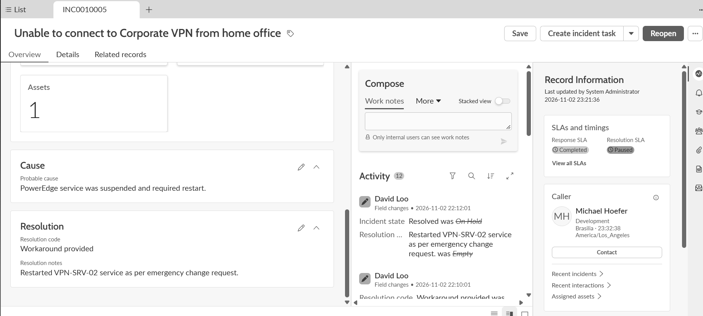
Cause and resolution on the Overview tab
9. Incident resolved
INC0010005 in Resolved state, with the history visible in Activity.
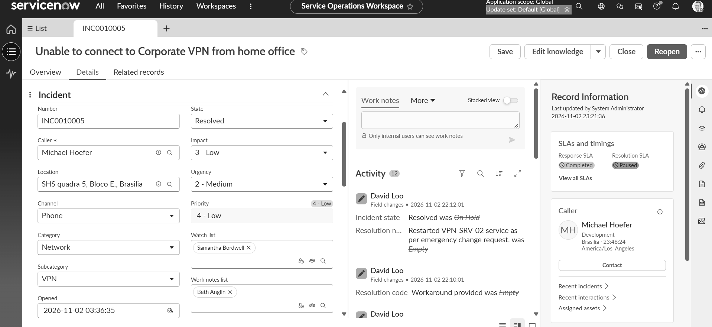
INC0010005 resolved
10. SLAs and new knowledge
Task SLAs, along with Created Knowledge (1) and Attached Knowledge (2) in Related records.
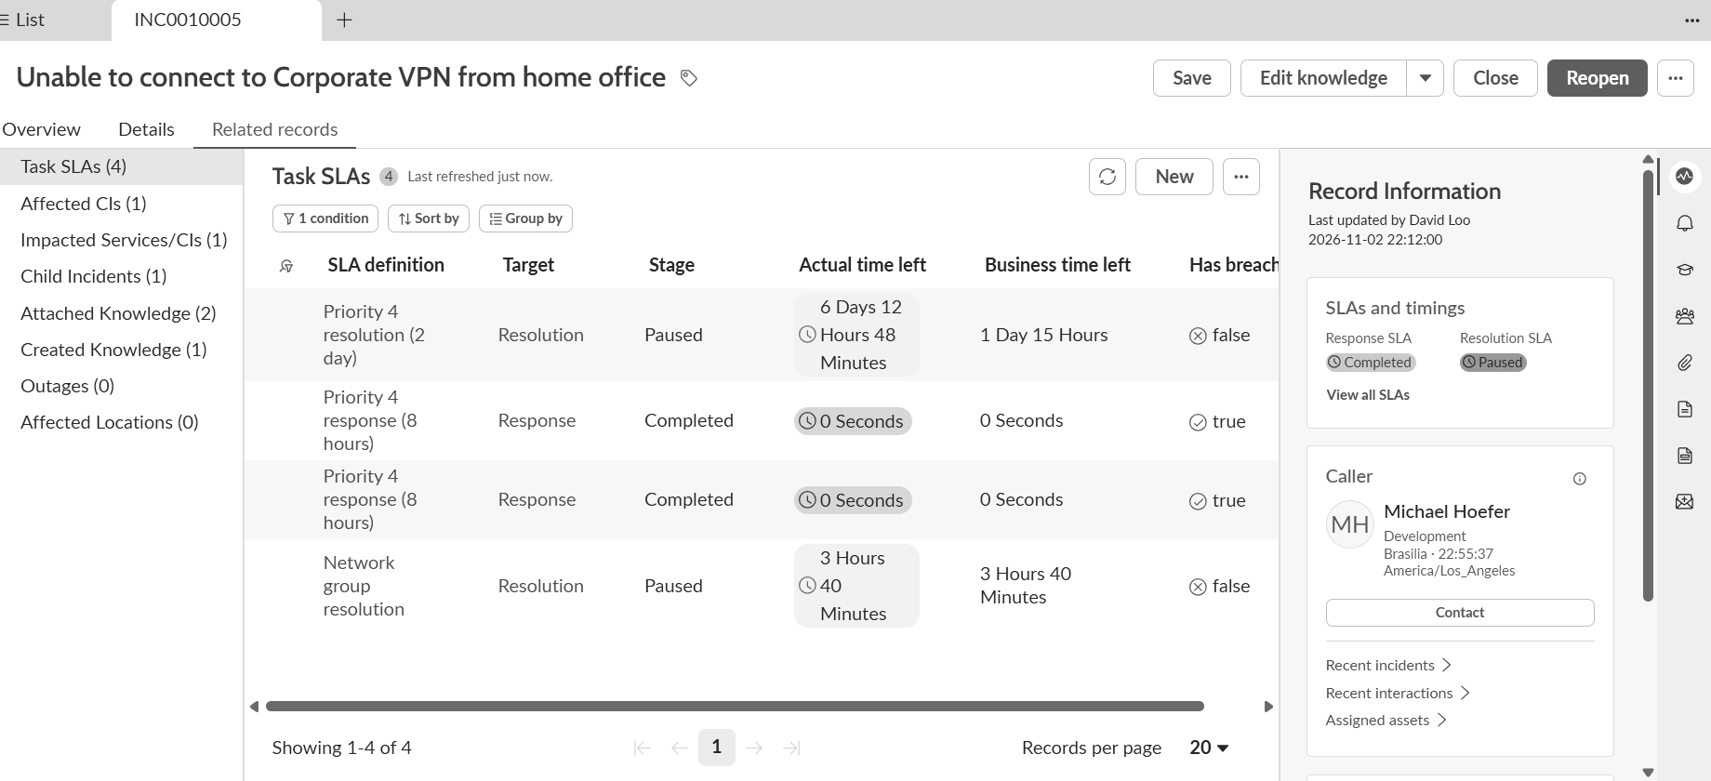
Task SLAs and knowledge counts

8. Advantages & Disadvantages

Advantages
- One record holds the whole lifecycle, so anyone can follow it in the Activity stream.
- Agent Assist puts known fixes in front of the agent while the SLA is running.
- Ownership is clear at every stage: first the Service Desk, then the Network Level 2 team.
- Emergency changes are recorded and tied to the incident they fix.
- Child incidents close with the parent, so duplicates are not left open.
- Every resolution can become a knowledge article for the next person.
- SLAs pause while the incident waits on a change, which keeps the compliance numbers fair.
- Built entirely through configuration, so there is no custom code to maintain.

Disadvantages
- It depends on clean reference data. A single spelling mistake in the service name stopped the offering from showing up.
- The knowledge approval flow can keep articles in Review until the knowledge base owner acts.
- Some actions, like creating an emergency change straight from the incident, depend on how the instance is set up.
- Knowledge user criteria can hide articles from agents unless access is configured for their roles.

9. Conclusion
This project shows a complete Incident Management lifecycle automation in ServiceNow. Service Desk agents can log and classify incidents, use knowledge to resolve them faster, escalate to Level 2 teams, raise emergency changes and document the final resolution properly. Bringing the Incident, Change and Knowledge modules together gives structured issue management, better SLA adherence and better IT service delivery.
Working on a real instance also taught me things the steps alone do not show, such as how approval flows, reference qualifiers and user criteria quietly shape what each user can see and do.

10. Future Scope
- Use assignment rules or Predictive Intelligence to route incidents to the right group automatically.
- Add a Virtual Agent so users can report VPN issues and get knowledge before an incident is even created.
- Use Problem Management for recurring VPN failures and publish a known-error article.
- Use Event Management to create incidents directly from server alerts on the PowerEdge CI.
- Build a Performance Analytics dashboard for SLA compliance, backlog and mean time to resolve.
- Send a short survey after resolution to measure caller satisfaction.

11. Appendix
Item | Details
Source Code | Not applicable. The project is configuration in ServiceNow with no custom scripts
Dataset Link | ServiceNow demo data (users, groups, CIs) on the Personal Developer Instance
Key Records | Service Remote Access, Offering Corporate VPN, Incident INC0010005, Child Incident INC0010006, Change CHG0030003, Knowledge KB0000008 (attached) and KB0010003 (created)
GitHub Link | Paste your GitHub link here
Project Demo Link | Paste your demo video link here

